HEALTHED
HEALTH EDUCATION

Bachelor of Science in Information Technology
IT-IPT02 MOBILE APPLICATION DEVELOPMENT

BSIT-4B
EIZEN MARC R. REGUYAL JR.
DANICA M. GARCIA
TRISHA MAE L. LANOZA
JOSHUA SEÑAL
ANDREI TORRES

Course Instructor
KARELLE Y. IBALE, LPT

December 15,2025

Abstract

HealthEd is a mobile application designed to enhance health education in high school. Many students fail to understand health lessons since traditional resources, such as textbooks, modules, or seminars, are usually long, technical, and not interactive. HealthEd responds to these problems by converting relevant health topics such as hygiene, mental health, nutrition, and first aid into simplified digital guides that can be easily read on the phones of the students.

This application will guide the students in learning about correct and reliable health information anywhere and anytime. Additionally, it is designed to infuse fun into learning as the app provides interactive tools that serve to test the knowledge of the students. The Ionic Framework is used for the system, along with an Angular interface, Capacitor for mobile compatibility, and backend services for user account storage, articles, and saved bookmarks. This will provide the students with accurate health information in a more modern and appealing way.

INTRODUCTION

Background

Health education plays a big role in the physical and mental development of teenagers. While they are in high school, their lives have to deal with many challenges: stress, poor hygiene habits, lack of sleep, unhealthy diet, and limited knowledge about first aid. Though schools teach some health lessons, learning materials tend to be too boring or technical to the students.

Students prefer information that they can access quickly on their mobile devices. Most health-related articles published online use complicated medical terms that are difficult for a student to comprehend. Further, some online sources also publish incorrect or misleading information that makes the learning of proper health practices more challenging. The observation of students relying heavily on their smartphones for their academic and non-academic purposes, such as schoolwork, entertainment, and communication, gave birth to the concept of HealthEd. Mobile technology is an intrinsic element of their daily routine today; it dawned that health education also needed to interface with this digitally lifestyles.

This application caters to the students' needs through the provision of easy and clear health information, simple articles that are concise and easy to comprehend, a friendly interface for young students, interactivity that will make them remember what they had learned. HealthEd connects the gaps in traditional health lessons with the digital habits of today's students. HealthEd is to increase the health awareness of high school students by providing easy access to dependable health information, brief guides on common health topics, and easy learning. It also should be engaging, interactive, and mobile-friendly. Besides, the app hopes to develop good health habits in students by embedding health learning into their daily routine.

STATEMENT OF THE PROBLEM

Health problems like stress, minor injury, wrong eating, or poor hygiene are many among high school students. Yet, not many of them know how to take care of the correct steps because health lessons are often too technical, books are not always at disposal or comfortable to carry, online information is sometimes exhaustive and unreliable, and traditional lessons do not encourage interaction. Sometimes, to that effect, the results turn out to be incorrect practices being followed or even ignored for a very important health issue.

Most of the mobile applications for health-related issues are targeted for adult uses, parents, or medical professionals. They may contain a detailed explanation of medications, professional tools like symptom checkers, instructions which might be too advanced for a school student to comprehend. Very few applications take into consideration straightforward health education for teenagers. There is a dearth of platforms that teach basic health habits in an interesting and understandable way.

SCOPE AND LIMITATIONS

Scope

User Authentication
Students can create an account and login safely. In this way, access to saved content or bookmarks will be provided in a personalized manner.
Dashboard
Simple home screen giving direct access to the main sections of the app. It shows a welcome message and navigation buttons.
Explore Feature
This leads the students to the section on interactive learning, where activities are outlined that will help them remember health information.
Library Module
A set of clear, concise health guides, all divided up into categories like Hygiene, Mental Health, Nutrition, First Aid. Each guide explains the topic in simple words so that students understand it quickly.
Book Marks
Students are able to save major articles for later quick access. This will definitely be helpful while studying or in times of emergencies.
Integration with Database
It pulls data from the backend, which stores user information and article bookmarks. This ensures that the contents are updated and organized.

Scope Limitations

The following are excluded from the app like Role-based access-no admin or teacher accounts, Analytics tracking or progress tracking, Full iOS support and deployment, The features for messaging or chat.Advanced medical tools include symptom checkers. These features may be added in future versions.

Related Systems Review
1. WebMD Mobile App WebMD is designed as a broad, medical-based application. It is a web-based digital encyclopedia with advanced symptom checkers and detailed disease and treatment information. The application is not quite friendly for students in high school since it contains many complex medical terminologies and a text-heavy display, which makes it hard to understand the basic concepts of health. This means that it is more suitable for use by adults for diagnosis rather than by youngsters for educational purposes. WebMD. (n.d.). WebMD Mobile App. https://www.webmd.com/mobile
2. Red Cross First Aid The Red Cross First Aid application is a specialized tool that will walk an individual through specific, step-by-step procedures in emergency situations from burns and fractures to cardiac arrest. It does include some useful offline access and video tutorials that greatly enhance its ability to be used during an actual crisis when internet connectivity may be in short supply. However, it is a purely passive tool-a reference source without daily wellness subjects or gamelike activities to stimulate students' interest over time. American Red Cross. (2025). Mobile Apps & Voice-Enabled Skill.
https://www.redcross.org/get-help/how-to-prepare-for-emergencies/mobile-apps.html
- Quizlet / Kahoot! Both Quizlet and Kahoot! are educational platforms using the strategy of gamification, through competitive quizzes and leaderboards, to increase student interaction in and among a wide variety of academic subjects. They are indeed wonderful for motivation but remain highly dependent on user-generated content and therefore cannot guarantee that medical accuracy so crucial for health education. For this reason, they do not have the structured, verified health curriculum a dedicated system like HealthEd offers.Kahoot! 2025. Research and efficacy: How Kahoot! Works
https://kahoot.com/research/

Strength
The HealthEd application is fun to use, which helps keep students interested in learning. The interactive components, such as quizzes, tasks, and feedback notifications, make learning a fun activity that is less boring. The application is easy to use, making it ideal for teenagers, which helps keep students interested in learning because they can easily comprehend the educational components.

Weakness
Although interactive, HealthEd does not have to be considered a reliable source of health education on its own. Certain aspects of health education might need to be verified by licensed health care providers to confirm whether the information is accurate. The application utilizes mobile devices and the availability of the internet for certain functions, which might inhibit use within a class setting where the use of technology is limited.

Comparison and Innovation
HealthEd integrates accurate health information, a simple and intuitive interface suitable for teenagers, and interactive learning activities in comparison with other similar existing applications. These features make the application more appropriate and effective for health education in senior high school environments.

Methology

Development Approach The development process of HealthEd is carried out in a manner that ensures all functionalities are working properly on mobile devices.

Tools and Technologies
Framework: Ionic Framework (v7).
Frontend Library: Angular (v16
Native runtime: Capacitor
Local Storage: Ionic Storage / Firebase

Development Tools: Visual Studio Code (IDE), GitHub (VCS), Android Studio (for preparing the APK file).

System Development Life Cycle (SDLC) – Agile We adopted the use of the Agile Methodology. This is because the methodology promotes improvement with every iteration of the development life cycle.
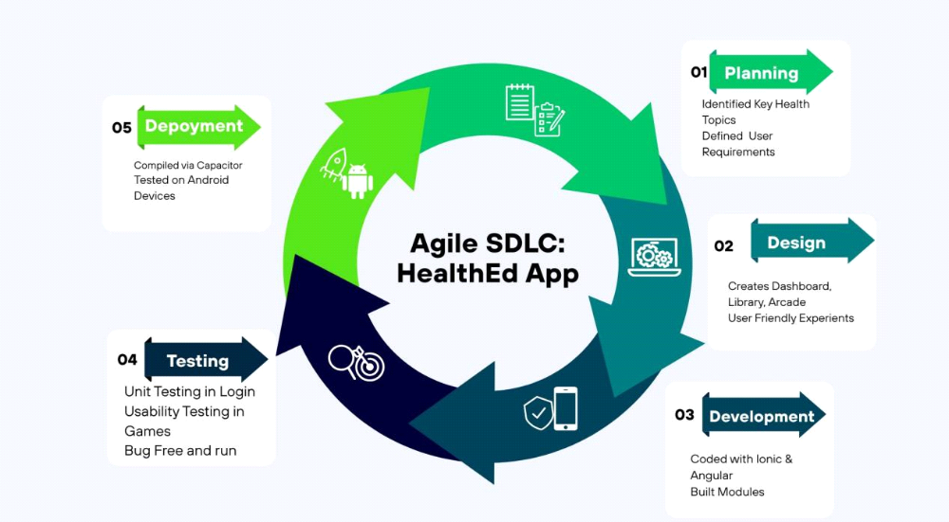
Planning
The group has been able to identify the common health issues that students encounter. In addition, the group has been able to list the attributes that are required within the application.

Design
For every page, such as Login, Dashboard, Library, Explore, prototypes/ wireframes were developed

Development
The software developers worked on developing the application component by component, starting with authentication, followed by the dashboard, and ending with the library component.

Testing
The application has been tested to ensure that it is functioning properly. Problems such as loading slowly, design flaws, etc. are corrected.

Deployment
The application has been developed on Android devices. The functionality of the application has been tested by the development team.

SYSTEM FEATURES / FUNCTIONAL DESCRIPTION (Expanded)

1. User Authentication
Goal: Protect user data; ensure safe, secure, and reliable access
Input Values: Email, password
Outputs: Error message on the home page/login page
User Process:The user launches the application. Types log-in credentials. System verifies the correctness of the information. User is redirected to the Dashboard.

2. Dashboard
Relevance: Main page for navigation
User Process:User logs in Sees welcome message, Chooses options such as Library or Explore.

3. Library Module
Aim: To develop easy-to-follow guides on health issues
User Process: User clicks on “Library"
Category Selection (for instance, "First Aid")
Reads the article that has been selected Can save it using the Bookmark.

- Health Arcade Module
Aim: Learn in a way that is fun
User Process: User clicks on 'Explore' , Chooses an interactive activity, Performs tasks and Receives feedback.

IMPLEMENTATION (Expanded)

The HealthEd app was designed as a Single Page Application for loading speed and great responsiveness. The app communicates with cloud-based backend services through secure API calls. On student login, the application forwards the credentials to Firebase Authentication for verification. After being authenticated, Firebase sends back a secure token keeping the user logged in and enabling access to protected parts of the app.
Cloud Storage and Offline Capability
The HealthEd application uses Firebase Cloud Firestore in addition to Ionic Storage to persist bookmarks and user data instead of SQLite. Bookmarks and selected contents would sync with Firebase so that students could access saved articles across devices. For offline usage, Ionic Storage caches data of bookmarked contents on the device temporarily. This will enable students to view previously saved health articles even when the internet is not connected. Whenever the device reconnects to the internet, the application automatically syncs the data to Firebase to ensure that all bookmarks and updates remain consistent.
Team Members’ Contribution and Roles

Member Name | Role | Specific Contributions
Joshua Señal | Project Manager | Coordinated meetings, timeline management, documentation review
Eizen Marc Reguyal | Lead Developer | Backend coding, database design, API development
Trisha Mae Lanoza | UI/UX Designer | Wireframes, mobile/web interface design, user testing
Danica Garcia | QA/Tester | Test cases, debugging, feature validation
Andrei Torres | Researcher/Documenter | Literature review, system study, writing of Chapters 1–3

